Apparel Identification using Neural Network
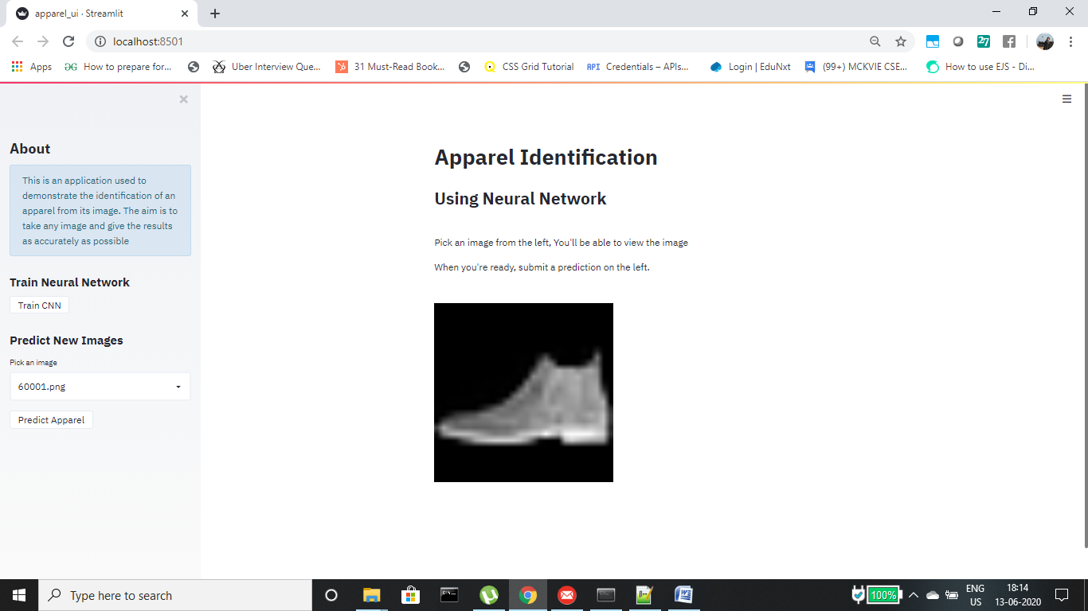
Step 1: A page opens with a side bar containing a button to train the model, a drop down menu from which images can be selected and a button to predict the apparel.

Step 2: On clicking the “Train CNN” button there are 2 possible outcomes.
- 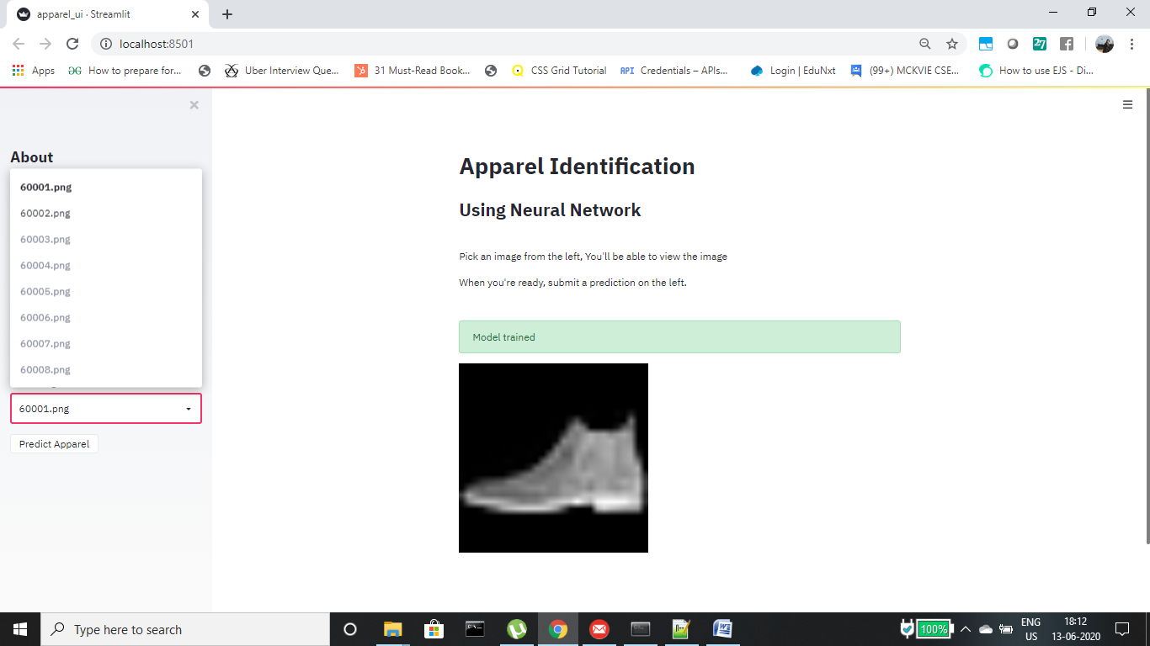If the model is already trained, then the “Model trained” message appears
- If the model needs to be trained then a message prompting “Training in progress..” appears. On completion a success message is displayed “Finished” and the model is stored in a models folder using the model.save method in keras.

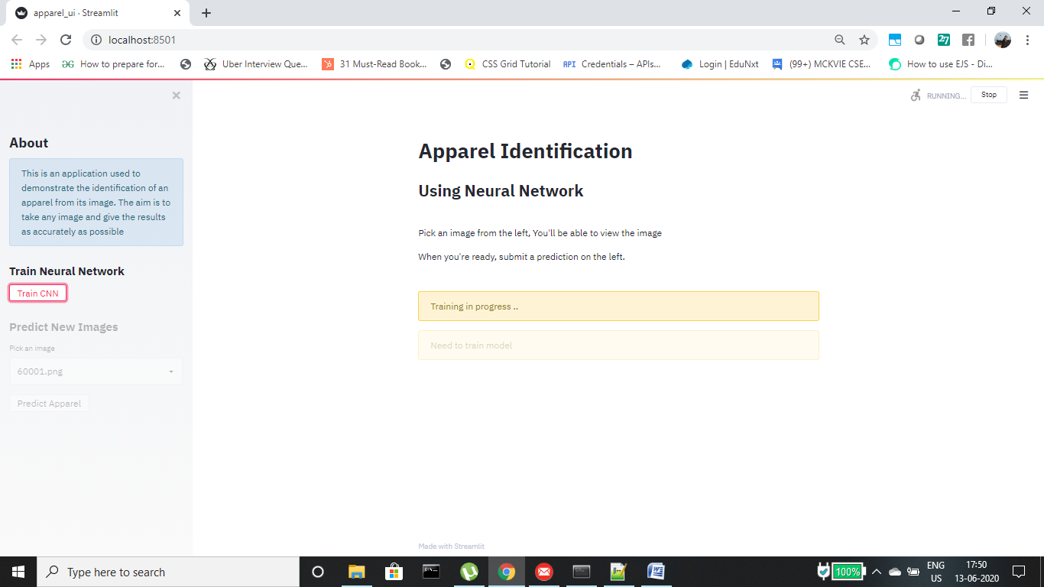
Step 3: From the drop down menu, the user can select the images they want to train. On selecting the image, it is displayed in the main area for the user to preview


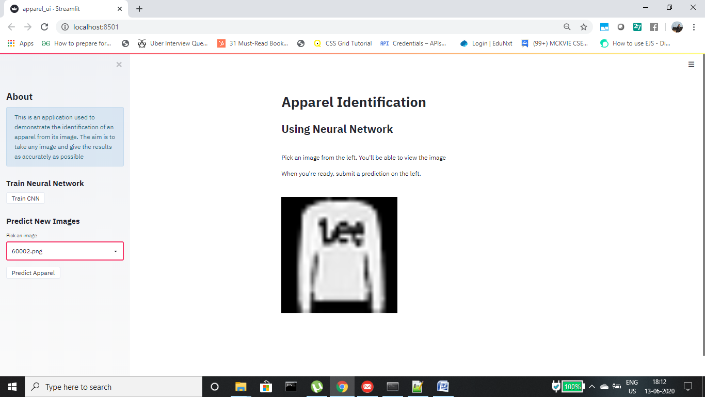
Step 4: Below the select box / drop down menu, is a button labelled “Predict Apparel”. On clicking this there are 2 possible outcomes.
- If the model is not trained, then a “Need to train model” message appears.

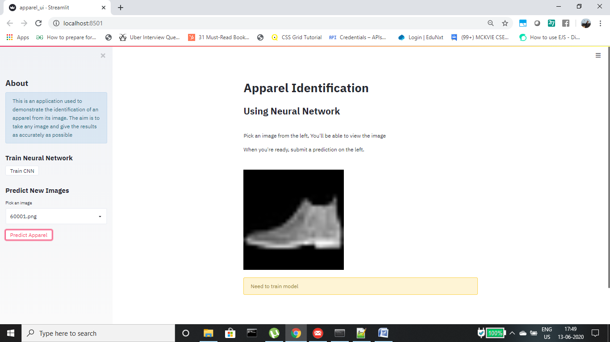

- If the model is trained then the model along with the image is sent for testing and the returned result is printed as prediction.

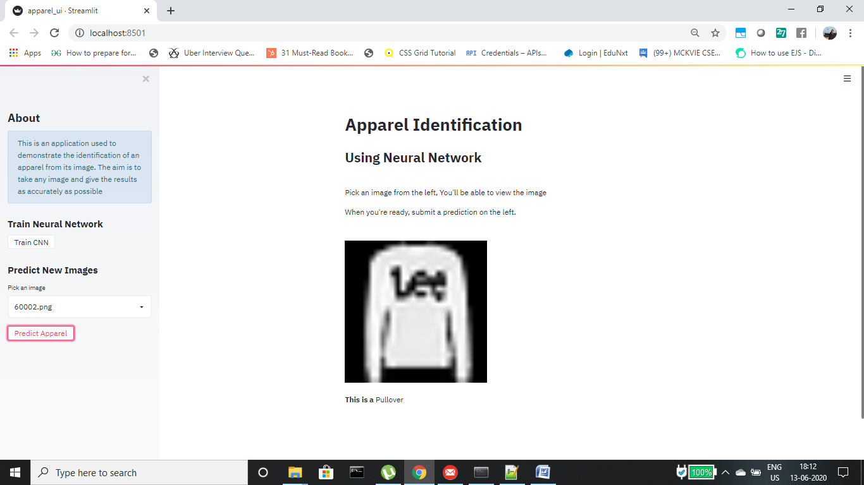
The package used for the creation of the UI is streamlit

